PHASE III: REQUIREMENT ANALYSIS
Date | 06 November 2025
Team ID | NM2025TMID08097
Project Name | To supply Leftover Food to Poor
Maximum Marks | 4 Marks

Title: Requirement Analysis for “FoodConnect – To Supply Leftover Food To Poor”

1. Objective
The Requirement Analysis Phase focuses on identifying, defining, and validating the specific requirements needed to implement FoodConnect on the Salesforce platform.
This phase ensures that every functional and technical aspect aligns with project goals, minimizes ambiguity, and provides a clear roadmap for development and testing.

2. Scope of the System
The FoodConnect system aims to automate the collection, tracking, and distribution of surplus food between donors (venues) and NGOs (recipients) through volunteers.
The scope includes:
- End-to-end data management using Salesforce objects.
- Automated task creation and allocation to volunteers.
- Secure and role-based access control.
- Dashboard-based analytics for transparency.
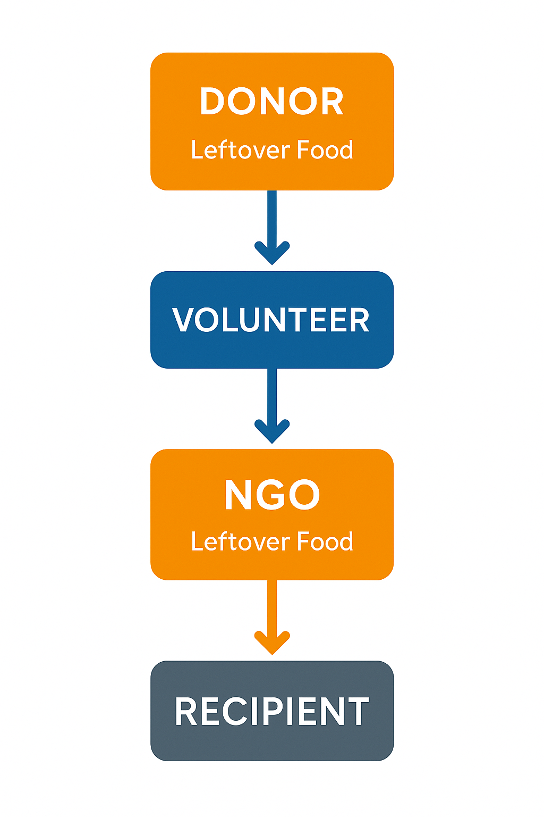

3. Functional Requirements
The functional requirements define what the system must perform. These are directly mapped to Salesforce features and modules.

3.1 Core Functional Modules
Module | Functionality | Salesforce Feature Used
Venue Management | Register donors, update contact info, and food details | Custom Object + Flow
Drop-Off Point Management | Manage NGO and shelter details | Custom Object
Task Allocation | Assign food pickup and delivery to volunteers | Flow + Trigger
Execution Tracking | Monitor delivery completion and performance | Master-Detail Relationship
Volunteer Management | Track volunteer availability and feedback | Custom Object
Dashboard Reporting | Visualize total deliveries, distances, and volunteer ratings | Reports + Dashboard Builder

3.2 System Workflow
- Donor (Venue) creates a food donation record.
- System automatically generates a Task Record for available volunteers.
- Volunteer receives the assignment and updates status post-delivery.
- Execution Details Record is automatically created upon completion.
- Dashboard reflects real-time performance metrics.

4. Technical Requirements
The technical requirements focus on the tools, components, and platform configurations necessary for implementation.
Category | Requirement | Description
Platform | Salesforce Developer Edition | Cloud-based CRM for automation and data management
Programming | Apex (Trigger) | Automates distance formula execution
Automation Tool | Salesforce Flow | Automates venue creation and volunteer assignment
Database | Salesforce Objects | Stores structured records for Venues, Tasks, etc.
Visualization | Salesforce Dashboard | Displays key performance metrics
Security | Profiles, Public Groups, and Sharing Rules | Ensures safe data access by role

4.1 Software Tools
- Salesforce Lightning Experience
- Flow Builder
- Schema Builder
- Developer Console
- Dashboard & Report Builder

4.2 Hardware Requirements
Component | Minimum Specification
Processor | Intel i3 or higher
RAM | 4 GB minimum
Storage | 512 MB for Salesforce Cache
Internet | Stable 2 Mbps connection
Browser | Chrome / Edge (latest)

5. Non-Functional Requirements
These requirements define system performance, usability, reliability, and security characteristics.
Category | Requirement | Description
Performance | System must handle 100 concurrent users | Ensured by Salesforce multi-tenant architecture
Scalability | Should support multiple NGOs in future | Achieved via dynamic object linking
Security | Role-based data access | Controlled using Profiles & Public Groups
Usability | Easy navigation for all users | Ensured by Lightning App structure
Reliability | 99.9% uptime | Managed through Salesforce Cloud
Maintainability | Low-code platform for easy updates | Supported by declarative tools

6. Data Model Design
The Data Model defines how different objects interact and store essential data.
Object | Key Fields | Relationship Type
Venue | Venue Name, Email, Phone, Location | Lookup to Drop-Off Point
Drop-Off Point | Drop-Off Location, Distance | Formula from Venue
Task | Task ID, Food Category, Volunteer Assigned | Master-Detail with Execution Details
Volunteer | Volunteer ID, Contact Info, Availability | Lookup to Task
Execution Details | Task Reference, Date, Rating | Master-Detail with Task
Distance Formula Used:
DISTANCE(Drop_Off_Point_Location__c, Venue__r.Geolocation__c, 'km')
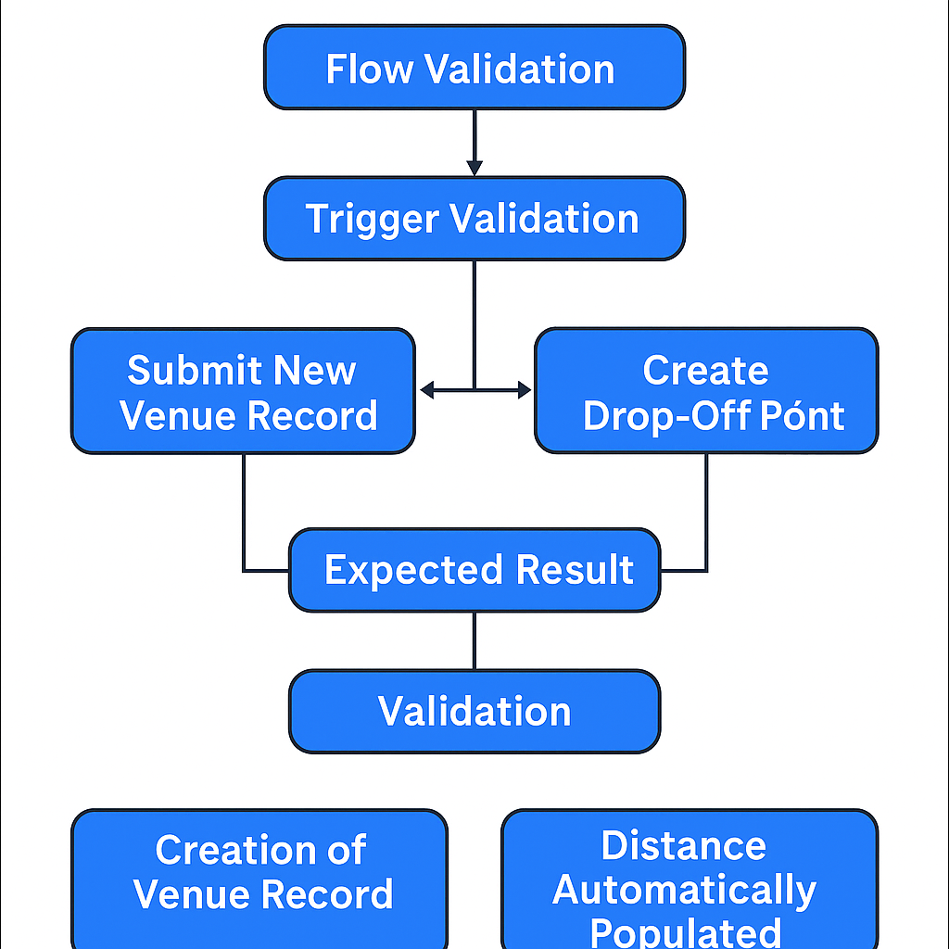

7. User Interface (UI) Requirements
The UI design is created in Salesforce Lightning App with 5 navigation tabs:
- Venues
- Drop-Off Points
- Volunteers
- Tasks
- Execution Details

7.1 UI Expectations
- Modern and clean interface
- Simple record creation via Flow Screen
- Responsive layout for different devices
- Embedded Dashboards on the Home Page
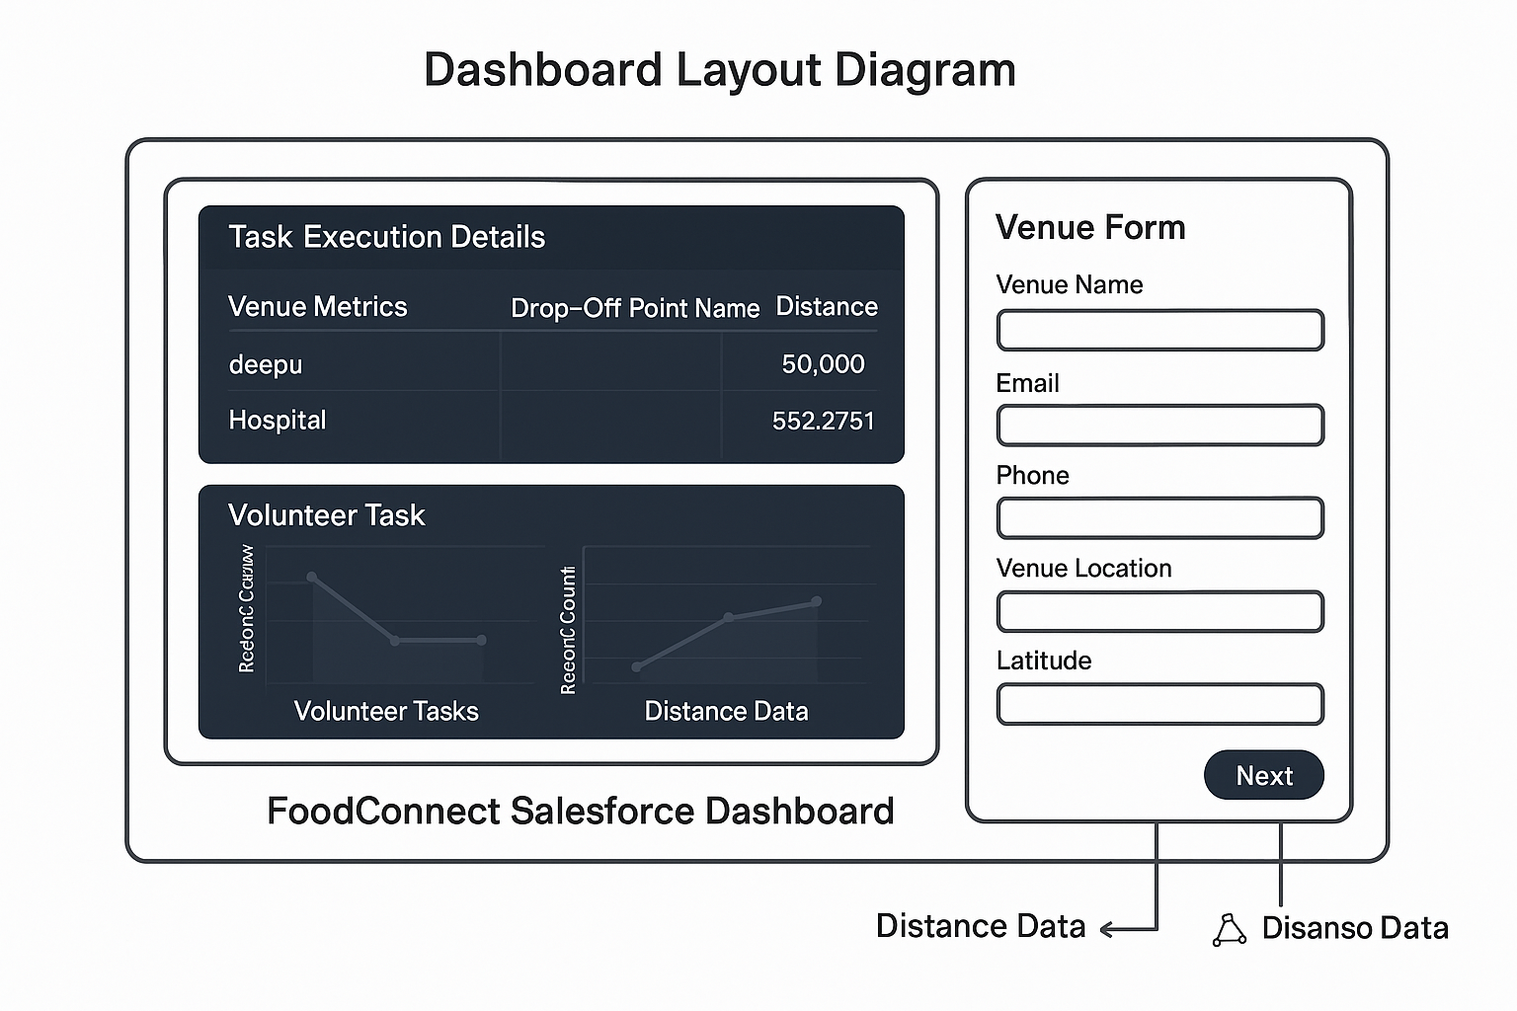

8. System Validation Requirements
Test Area | Description | Expected Output
Flow Execution | Venue Form creates record correctly | Record created successfully
Trigger Validation | Distance auto-calculated | Distance displayed in km
Dashboard Display | Reports updated automatically | Real-time visual update
Profile Access | Volunteers limited to their records | Restricted access confirmed

9. Risk Identification and Mitigation
Risk | Description | Mitigation Strategy
Data Loss Risk | Accidental deletion by user | Enable Recycle Bin & Backup
Access Conflicts | Incorrect profile permission | Regular audits of sharing settings
Network Downtime | Cloud dependency | Offline data export for reports
Automation Failure | Trigger or Flow error | Include debug logs and test classes

10. Summary
The Requirement Analysis Phase solidifies the blueprint for the FoodConnect system.
By carefully identifying all functional, technical, and non-functional requirements, the project is fully prepared for the Design and Implementation Phase.
Key achievements of this phase:
- Complete mapping of system entities and relationships
- Defined UI and automation requirements
- Established validation and risk control procedures
- Ensured platform scalability and sustainability
This phase guarantees that the project remains structured, feasible, and purpose-driven throughout its development lifecycle.

